**Learning Activity 4-02**

**Is about:**

* Perform SELECT queries on a single table with simple selection conditions.

**Goals:**

* Edit and execute SELECT statements on a table according to the required requirements.
* Use the WHERE clause within the SELECT statement.
* Select rows by conditions over text and/or enumerated columns.
* Select rows by conditions over numerical columns.

**Procedure**

**In a mysql client, open the world database to perform the following data queries.**

1.- Obtain the country code Spain.

**SELECT code FROM country WHERE name='spain';**

2.- Obtain the names of all the cities in Spain along with their population.

**SELECT name,population FROM city WHERE countrycode='ESP';**

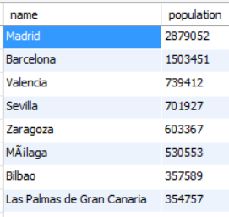

3.- Obtain the names and population of all the cities in Spain that have more than 250,000 inhabitants, ordered by number of inhabitants from largest to smallest.

**SELECT name,population FROM city WHERE countrycode='ESP' AND population>250000 ORDER BY population DESC;**



4.- Obtain all the languages ( **countrylanguage table)** that are spoken in Spain with the percentage of people who speak it.

**SELECT language,percentage FROM countrylanguage WHERE countrycode='ESP';**

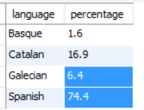

5.- Get all the countries of Europe arranged alphabetically. Since the continent column is **enum** , you can compare the continent to the text literal of the continent name or to the position number of the continent in the **enum declaration** in the table layout. Make the query in both ways.

**SELECT name FROM country WHERE continent='europe' ORDER BY name;**

**SELECT name FROM country WHERE continent=2 ORDER BY name;**

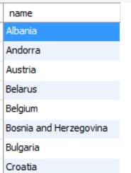

6.- Obtain the names of all the regions **(district)** to which cities of

Russia (RUS code).

It would be better with:

**SELECT DISTINCT district FROM city WHERE countrycode='RUS';**

Since this way the district is not repeated.

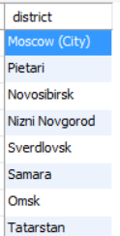

7.- Obtain the name, population, gross national product (GNP), per capita income (GNP/population) of all the countries in Africa and Asia.

**SELECT name,population,gnp,gnp/population AS rpc FROM country WHERE**

**continent='africa' OR continent='asia';**

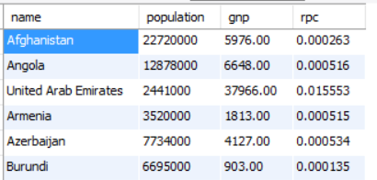

8.a.- Obtain the name, continent, population, gross national product (GNP), per capita income (1000000*GNP/population) of all the countries in the world except those in Europe, ordered by per capita income.

**SELECT name,population,gnp,1000000*gnp/population AS rpc FROM country WHERE**

**continent!='europe' ORDER BY rpc;**

Also works:

**SELECT name,population,gnp,1000000*gnp/population AS rpc FROM country WHERE NOT continent='europe' order by rpc;**

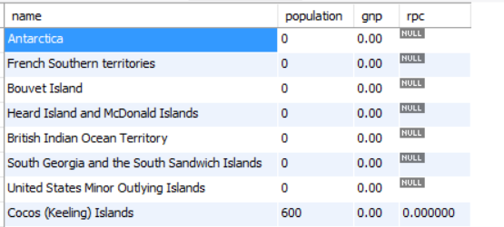

8.b.- Obtain the name, continent, population, gross national product (GNP), per capita income (1000000*GNP/population) of all the countries in the world except those of Europe, ordered by continent and as a second criterion by per capita income. capita.

**SELECT name,** continent, **population,gnp,1000000*gnp/population AS rpc FROM country WHERE**

**continent!='europe' ORDER BY continent,rpc;**

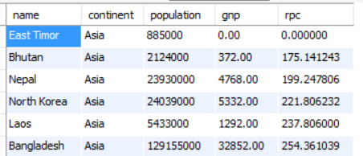

9.a.- Obtain a list of the languages spoken by more than 90% in a country and

each country code in which they are spoken. The list should appear alphabetically by language.

**SELECT language,countrycode** , **percentage FROM countryLanguage WHERE**

**percentage>90 ORDER BY language;**

9.b.- Obtain a list of the languages spoken by more than 90% in some country (languages should be listed without repeating).

**SELECT DISTINCT language FROM countrylanguage WHERE percentage>90;**

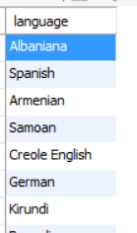

10.- Obtain the name and life expectancy of all the countries in Africa whose life expectancy is between 55 and 65 years.

**SELECT name,lifeexpectancy FROM country WHERE continent='africa' AND**

**lifeexpectancy>=55 AND lifeexpectancy<=65;**

**SELECT name,lifeexpectancy FROM country WHERE continent='africa' AND**

**lifeexpectancy BETWEEN 55 AND 65;**

